White Paper

A new bicycle-sharing system with blockchain

Introduction

During these year, I realize that we met a new area of b2c shared economy. Last year, bicycle-sharing system developed rapidly in China. In some scene, it eliminated the biggest pain point of city’s public transportation problem which we call it “the last mile”. People enjoy the convenience via bicycles located all over the city which can connect the stations to their home. But, it also came along with the damaging and stealing of the shared-bicycle which is a very pathetic. In this case, some people think the bicycle-sharing industry will not success in the long run. On the other hand, some company like MOBIKE and OFO raised a few tens of billions funding in just a few months from the market. Optimists tend to assume that it is a very smart move to catch the business opportunity; pessimists may feel it is a commercial scam. All in all, shared-bicycle has suffered too much criticism over the past year, trust is the main problem no matter on the costumer side or the company side. At the same time, block chain technology is also very popular in the last year, it’s high autonomy and high security which are very needed in today’s society, some businessmen think it will play a key role in the future market. In my opinion, it will make up the shortcoming of the shared-bicycle, if we combine the block chain and bike-sharing system together, the new sharing system will be very efficiently and trustful and it will easily acquire its position on the market.

Background

Not only China, as long as the society which population base is large enough, it will come with the problem which caused by the difference of people’s quality. We cannot fix the problem by relying on people’s self-discipline and also there are some phenomena which are not bound by law, that’s why I want to use block chain to help us solve the problem.

Block chain as a peer to peer distributed system which has the characteristics of transparent, anonymous and transport immutable. It can reduce the time and cost of using the third party to keep the relationship with the company and costumers. Especially it can keep the system work efficiently and help to reduce the risk of human error.

As far as I am concerned, there are two main problems in the bike-sharing system:

1. Disorderly parking: according to my observation during the time I was in china, it is normal that different colors sharing bike parked disorderly in front of the entrance of metro station, some even just park in the middle of the bicycle lane and sidewalk.
2. Dead bike problem: In some bustling commercial center, during the peak period, the bike using will have the one-way phenomenon, it cannot form a cycle use. Many costumers just park the bike as will, without thinking the next costumer who may not find the bike easily.

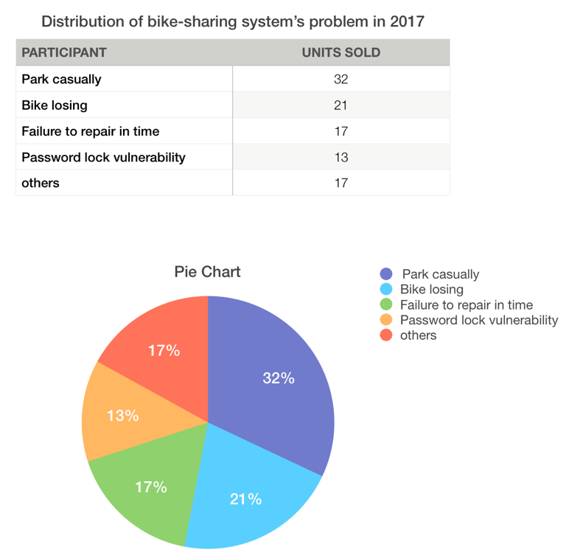

These numbers are come from ii-media research which showed several problems the system have in the 2017. Hopefully, we can use block chain technology to solve these problems.

Solution

First, I prefer to build the system on Ethereum, it is a block chain that allow you to run programs in its trusted environment. Ethereum has virtual machine, called the Ethereum Virtual Machine(EVM). It allows code to be verified and executed on the block chain, providing guarantees it will be run the same way on everyone’s machine. Our job is to write the smart contract and front-end logic for the bike-sharing system.

The token of my block chain is called BKCoins, it will surport the reward and scoring system, people can use BKCoins to pay their fee of biking and using BKCoin to recharge their virtual wallet. Also, we encourage people to ride which can protect the environment and good to their health, the more distance they ride, the more BKcoins they will be rewarded.

Also, we use the reward and punishment system to manage the bike’s using. Also, BKcoin has the trading ability. Customers can use BKcoin to buy some merchandise which related to biking in our specific stores.

REWARD:

1. At first, when people sign up account in the bike-sharing system, they will get 10 BKcoins which can help them to pay the fee of biking 1 hour.
2. People can get the coin by parking the bike at some specific locations which will not influence the city’s transportation and cleaning.
3. if people find a damaged bike, they can report it to our system and they will also get some rewards. It will fix the problem of failure to repair the bike in time.
4. To fix the one-way transportation problem, we will set a reward for the opposite direction like double reward for the normal reward.

Punishment:

1. If someone who damaged the bike without report, they will pay the penalty for the repair fee.
2. The account information will link to their personally information, if someone losing the bike and without paying the penalty their account will be blocked and can never appeal another account except after they paid the penalty.
3. When people finish biking, the system will write down the location they park, if they park in the middle of the street of sidewalk which will influence the transportation, they will get 50 bkcoins penalty. And they will be recorded in the block which will influence the amount they get coins by biking.
4. We will tracing the bike using time, they cannot using the deceive methods like move the bike by cars to earn the BKcoin, if they did that, the account will be blocked forever.

Conclusion:

According to our research, because of the high-cost and expensive maintenance, many bicycle-sharing companies had run out of cash and have to close down. According to the advisory, costumer’s loss of the deposit in the bike-sharing system had reach 2 billion in China. We can see, there are really severe problem of trust between the company and costumers. I believe BKcoin will help us to fix this problem and it have really bright future in the market.